Abdulrahman Al-Nachar

CS340/ 3-1

**Part I: Importing and Indexing a Data Set**

Step 1:

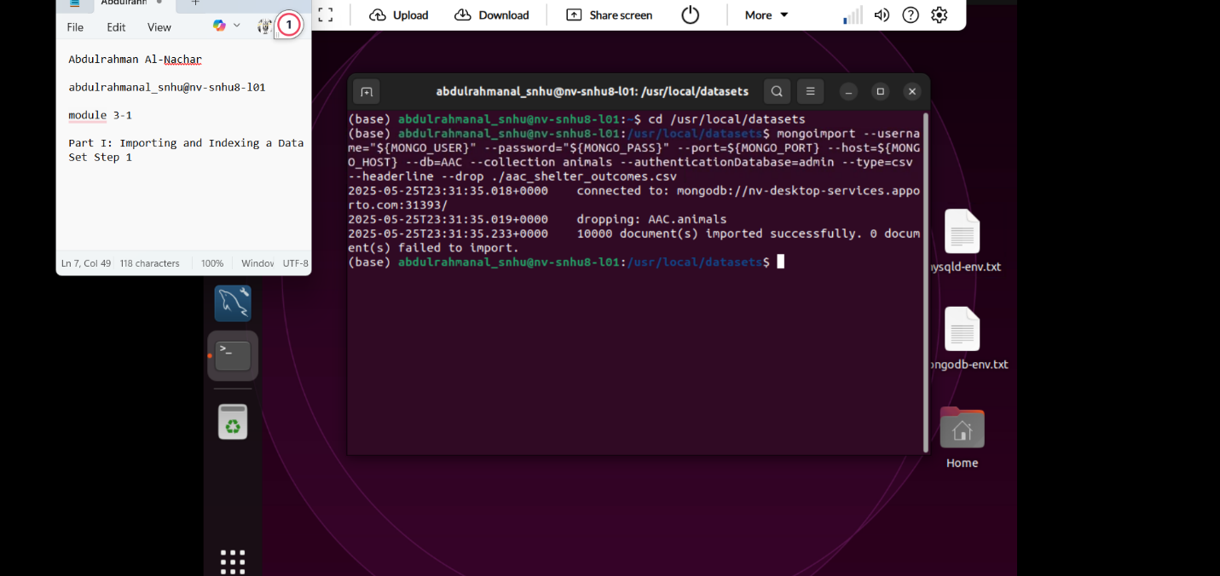

Step 2:

Step 3:

**Part II: User Authentication**

Step 4:

Step 5:

Step 5 , Second User:

